American History II | Unit 2 – Imperialism and Isolationism: American Foreign Policy in the Modern Age
World War I at Home

What were some things accomplished by the following wartime agencies and laws?
War Industries Board |  | Railroad Administration | Fuel Administration
National War Labor Board |  | Food Administration | Committee on Public Information
Espionage and Sedition Acts

What changes did the war bring about for the following groups of Americans?
Immigrants | African Americans | Women
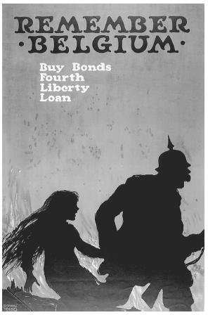
1. What symbols or images are used in the propaganda poster?
2. What messages or important words are used?
3. What does the government want the audience to do?
4. Do you think this poster is effective? Why or why not?
1.
4.
2.
3.
American History II | Unit 2 – Imperialism and Isolationism: American Foreign Policy in the Modern Age
Wilson Fights for Peace

1918 | Wilson delivers Fourteen Points speech to Congress. |  | What were Wilson’s points?
 |  |  | 1.
 |  |  | 2.
 |  |  | 3.
 |  |  | 4.
 |  |  | 5.
 |  |  | 6. – .13
 |  |  | 14.
1919 | Treaty of Versailles is signed. |  | What terms of the treaty specifically affected Germany?
 |  |  | What were the weaknesses of the treaty?
1.

2.

3.

4.

5.

6.

1920 | Senate rejects Treaty of Versailles |  | Why did Henry Cabot Lodge object to the treaty?
1921 | Senate again rejects Treaty of Versailles |  | How did Wilson help bring about the Senate’s rejection of the treaty?
 | U.S. signs separate treaty with Germany |  | What circumstances at this time would eventually lead many Germans to support Adolf Hitler?
 |  |  | 