The Tuskegee Airmen
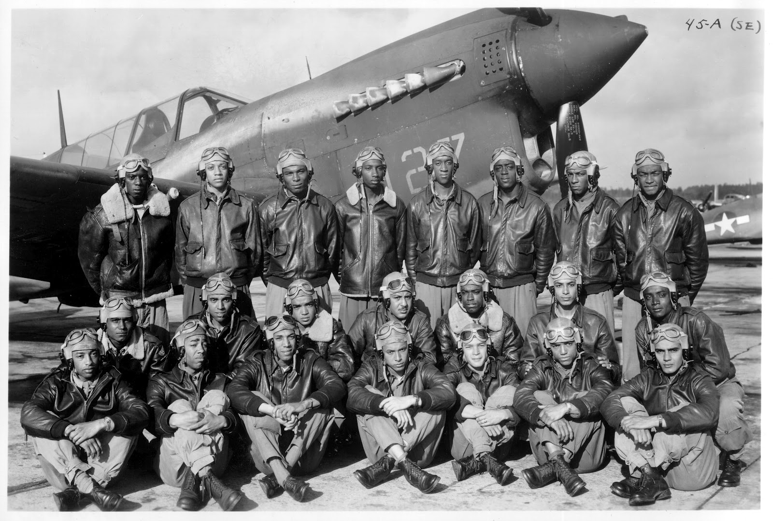

Instructions: You should watch the video(s) and read the text(s), then discuss and answer the questions. You will find the links for video and text on this website. Write down your responses and insert into your notebook for a grade. Be prepared to share your answers and ideas.

Introductory Reading: ‘The Tuskegee Airmen’ from history.com
“The Tuskegee airmen were the first black servicemen to serve as military aviators in the U.S. armed forces, flying with distinction during World War II. Though subject to racial discrimination both at home and abroad, the 996 pilots and more than 15,000 ground personnel who served with the all-black units would be credited with some 15,500 combat sorties and earn over 150 Distinguished Flying Crosses for their achievements. The highly publicized successes of the Tuskegee Airmen helped pave the way for the eventual integration of the U.S. armed forces under President Harry Truman in 1948.”

Introductory Video on the Tuskegee Airmen: http://www.history.com/topics/world-war-ii/tuskegee-airmen
Source # 1 (Online Article) The Tuskegee Airmen Overview: http://www.nps.gov/museum/exhibits/tuskegee/airoverview.htm
1. What led to the formation of the ‘Tuskegee Airmen’?

2. Who are the ‘Tuskegee Airmen’?

3. Why did the military choose to train black pilots in Tuskegee, Alabama?

4. What is the significance of the Tuskegee Airmen?
Source # 2 (Online Article) The Tuskegee Airmen in Combat: http://www.nps.gov/museum/exhibits/tuskegee/aircombat.htm
1. What kind of obstacles did the Tuskegee Airmen face?

2. How did the Tuskegee Airmen contribute to the war effort during World War 2?

3. According to the article, what impact did the Tuskegee Airmen make once they returned home from war?

4. What do you think is the legacy of the Tuskegee Airmen?

Source # 3 (Online Article) 5 Fascinating Facts About the Tuskegee Airmen: http://www.history.com/news/the-tuskegee-airmen-5-fascinating-facts
1. How did First Lady Eleanor Roosevelt help to support the Tuskegee Airmen?

2. Which of the 5 facts did you find to be most ‘fascinating’ and why?

Source # 4 (Online Video) Tuskegee Airmen Visit the White House: https://www.youtube.com/watch?v=NNpSwVBeXtI
1. How does this short video give you a better understanding of / appreciation for the Tuskegee Airmen?

2. If you could ask these men who served as ‘Tuskegee Airmen’ a question, what question would you like to ask them?

Airmen Overview

In spite of adversity and limited opportunities, African Americans have played a significant role in U.S. military history over the past 300 years. They were denied military leadership roles and skilled training because many believed they lacked qualifications for combat duty. Before 1940, African Americans were barred from flying for the U.S. military. Civil rights organizations and the black press exerted pressure that resulted in the formation of an all African-American pursuit squadron based in Tuskegee, Alabama, in 1941. They became known as the Tuskegee Airmen.
"Tuskegee Airmen" refers to all who were involved in the so-called "Tuskegee Experiment," the Army Air Corps program to train African Americans to fly and maintain combat aircraft. The Tuskegee Airmen included pilots, navigators, bombardiers, maintenance and support staff, instructors, and all the personnel who kept the planes in the air.
The military selected Tuskegee Institute to train pilots because of its commitment to aeronautical training. Tuskegee had the facilities, and engineering and technical instructors, as well as a climate for year round flying. The first Civilian Pilot Training Program students completed their instruction in May 1940. The Tuskegee program was then expanded and became the center for African-American aviation during World War II.
The Tuskegee Airmen overcame segregation and prejudice to become one of the most highly respected fighter groups of World War II. They proved conclusively that African Americans could fly and maintain sophisticated combat aircraft. The Tuskegee Airmen's achievements, together with the men and women who supported them, paved the way for full integration of the U.S. military.
On November 6, 1998, President Clinton approved Public Law 105-355, which established the Tuskegee Airmen National Historic Site at Moton Field in Tuskegee, Alabama, to commemorate and interpret the heroic actions of the Tuskegee Airmen during World War II. The new site will contain a museum and interpretive programs at the historic complex at Moton Field as well as a national center based on a public-private partnership.

https://www.nps.gov/museum/exhibits/tuskegee/airoverview.htm
Airmen in Combat

The 99th Fighter Squadron was sent to North Africa in April 1943 for combat duty. They were joined by the 100th, 301st, and 302nd African-American fighter squadrons. Together these squadrons formed the 332nd fighter group. The transition from training to actual combat wasn't always smooth given the racial tensions of the time. However, the Airmen overcame the obstacles posed by segregation. Under the able command of Col. Benjamin O. Davis, Jr., the well-trained and highly motivated 332nd flew successful missions over Sicily, the Mediterranean, and North Africa.
Bomber crews named the Tuskegee Airmen "Red-Tail Angels" after the red tail markings on their aircraft. Also known as "Black" or "Lonely Eagles," the German Luftwaffe called them "Black Bird Men." The Tuskegee Airmen flew in the Mediterranean theater of operations. The Airmen completed 15,000 sorties in approximately 1,500 missions, destroyed over 260 enemy aircraft, sank one enemy destroyer, and demolished numerous enemy installations. Several aviators died in combat. The Tuskegee Airmen were awarded numerous high honors, including Distinguished Flying Crosses, Legions of Merit, Silver Stars, Purple Hearts, the Croix de Guerre, and the Red Star of Yugoslavia. A Distinguished Unit Citation was awarded to the 332nd Fighter Group for "outstanding performance and extraordinary heroism" in 1945.
The Tuskegee Airmen of the 477th Bombardment Group never saw action in WWII. However, they staged a peaceful, non-violent protest for equal rights at Freeman Field, Indiana, in April 1945.
Their achievements proved conclusively that the Tuskegee Airmen were highly disciplined and capable fighters. They earned the respect of fellow bomber crews and of military leaders. Having fought America's enemies abroad, the Tuskegee Airmen returned to America to join the struggle to win equality at home.

https://www.nps.gov/museum/exhibits/tuskegee/aircombat.htm
The Tuskegee Airmen: 5 Fascinating Facts

1. The Tuskegee airmen once shot down three German jets in a single day.
On March 24, 1944, a fleet of P-51 Mustangs led by Colonel Benjamin O. Davis, commander of the Tuskegee airmen, set out on the longest escort mission their crews would fly during World War II. The 43 fighters were there to help B-17 bombers run a gauntlet of over 1,600 miles into the heart of Hitler’s Germany and back. The bombers’ target, a massive Daimler-Benz tank factory in Berlin, was heavily defended by whatever forces the Luftwaffe could muster at that point in the war. The 25 aircraft protecting the plant included the battle-tested Fw 190 radial propeller fighters, the Me 163 “Komet” rocket-powered plane and the much more formidable Me 262, history’s first jetfighter and the forerunner of today’s modern fighters. While the American P-51s typically lagged behind the Me 163s and 262s, they could outmaneuver them at low speeds. The German planes also tended to run out of fuel more quickly than the Tuskegee airmen’s Mustangs. Making the most of their limited advantages, pilots Charles Brantley, Earl Lane and Roscoe Brown all shot down German jets over Berlin that day, earning the all-black 332nd Fighter Group a Distinguished Unit Citation.

2. Thurgood Marshall, the future Supreme Court justice, got his start defending Tuskegee bomber trainees.
The 477th Bombardment Group was formed in 1944 to extend the so-called “Tuskegee experiment” by allowing black aviators to serve on bomber crews. The aim was to send pilots—many of them veterans of the original Tuskegee fighter group—back to the States for training on B-25 bombers. While in Indiana, some of the African-American officers were arrested and charged with mutiny after entering an all-white officers’ club. Thurgood Marshall, then a young lawyer, represented the 100 black officers who had landed in jail as a result of the confrontation. The men were soon released (although one was later convicted of violent conduct and fined).

3. The Airmen might have never gotten off the ground without Eleanor Roosevelt’s help.
In April 1941, months before the United States entered World War II, Eleanor Roosevelt visited Tuskegee Army Air Field in Alabama, where the Tuskegee airmen had begun training. Charles “Chief” Anderson, Tuskegee’s chief flight instructor at the time, offered to take the first lady around the field. Anderson had taught himself to fly years earlier in a used plane he bought with his own savings. Roosevelt agreed, and the photos and film that came out of the 40-minute flight helped convince people in power to support the creation of a black fighter group.

4. A former Tuskegee airman almost shot the late Libyan leader Muammar el-Qaddafi in a showdown outside of Tripoli in 1970.
Daniel “Chappie” James Jr. started his career in the early 1940s at Tuskegee, joining the Army Air Corps in July 1943. After the war ended, James stayed in what became the Air Force and flew missions in both Korea and Vietnam. In 1969 James was put in command of Wheelus Air Force Base outside of Tripoli. A year earlier, a coup led by Colonel Qaddafi had overthrown the country’s ruling monarch, King Idris. Qaddafi then ordered the closing of the large American base in the country he now controlled. But before a formal handover to the Libyan authorities could take place, Qaddafi pushed his forces onto the base. James later recalled the standoff that followed: “One day [Qaddafi] ran a column of half tracks through my base—right through the housing area at full speed. I shut the barrier down at the gate and met [Qaddafi] a few yards outside it. He had a fancy gun and a holster and kept his hand on it. I had my .45 in my belt. I told him to move his hand away. If he had pulled that gun, he never would have cleared his holster. They never sent any more half tracks.”

5. Three Tuskegee airmen went on to become generals.
For keeping his cool in the face of Qaddafi’s troops, Daniel James was appointed a brigadier general by President Nixon. He wasn’t the only graduate of the “Tuskegee experiment” to make flag rank, however. James followed in the footsteps of Benjamin O. Davis Jr., the original commander of the 332nd Fighter Group and the first black general in the U.S. Air Force. Another Tuskegee aviator, Lucius Theus, retired a major general after dedicating most of his 36-year career in the Air Force to improving the military’s bureaucracy, helping to implement a direct deposit system for service members.

https://www.history.com/news/the-tuskegee-airmen-5-fascinating-facts

