Introductory Reading: The Harlem Renaissance (1917 – 1935), from pbs.org
“The Harlem Renaissance was the name given to the cultural, social, and artistic explosion that took place in Harlem between the end of World War I and the middle of the 1930s. During this period Harlem was a cultural center, drawing black writers, artists, musicians, photographers, poets, and scholars. Many had come from the South, fleeing its oppressive caste system in order to find a place where they could freely express their talents...
The Renaissance incorporated jazz and the blues, attracting whites to Harlem speakeasies, where interracial couples danced. But the Renaissance had little impact on breaking down the rigid barriers of Jim Crow that separated the races. While it may have contributed to a certain relaxation of racial attitudes among young whites, perhaps its greatest impact was to reinforce race pride among blacks.”

Great Migration & The Harlem Renaissance WebQuest
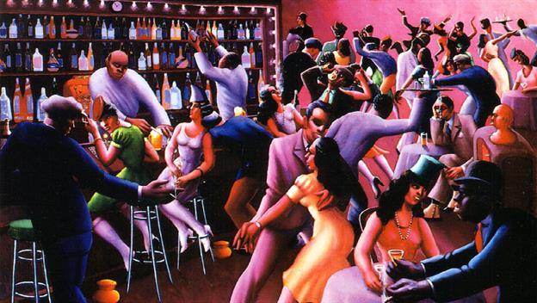

Instructions: You should watch the video(s) and read the text(s), then discuss and answer the questions. You will find the video and text on this website. Write down responses on your question sheet.
Part 1: Great Migration - https://www.history.com/topics/black-history/great-migration

1. How many African Americans moved during the Great Migration? And where
did they move to?

2. Why did African Americans move?

3. Why did people start recruiting African Americans to go up North?

4. Between 1910-1920, what 4 major cities did African Americans move to?

5. Why did African Americans create their own cities within a city?

6. What was the biggest African American community called in New York City?

How many people lived in this community?

7. When did the Great Migration end?

8. How many African American people lived in the South when the Great Migration was over?

Part II. Introductory Video on the Harlem Renaissance:

http://www.history.com/topics/roaring-
https://www.history.com/topics/black-history/harlem-renaissance

After viewing the videos, answer the following questions:
Source # 1 : Poems by Langston Hughes
“I Too Sing America” by Langston Hughes
“I, too, sing America.
I am the darker brother.
They send me to eat in the kitchen
When company comes,
But I laugh,
And eat well,
And grow strong.
Tomorrow,
I'll be at the table
When company comes.
Nobody'll dare
Say to me,
"Eat in the kitchen,"
Then.
Besides,
They'll see how beautiful I am
And be ashamed--
I, too, am America.”

1. Based on this poem, ‘I Too Sing America', what is Hughes’ attitude towards racial discrimination?

2. What is his vision of the future for African-Americans in America?

“Mother to Son” by Langston Hughes
“Well, son, I'll tell you:
Life for me ain't been no crystal stair.
It's had tacks in it,
And splinters,
And boards torn up,
And places with no carpet on the floor,
Bare.
But all the time
I'se been a-climbin' on,
And reachin' landin's,
And turnin' corners,
And sometimes goin' in the dark
Where there ain't been no light.
So, boy, don't you turn back.
Don't you set down on the steps.
'Cause you finds it's kinder hard.
Don't you fall now.
For I'se still goin', honey,
I'se still climbin',
And life for me ain't been no crystal stair.”

3. What message is Hughes trying to communicate to his reader in his poem ‘Mother to Son’?

4. How does Hughes' use of grammar and language help contribute to the "feeling" of the poem?

Source # 2: (Painting) Archibald J. Motley, Blues, 1929, oil on canvas.
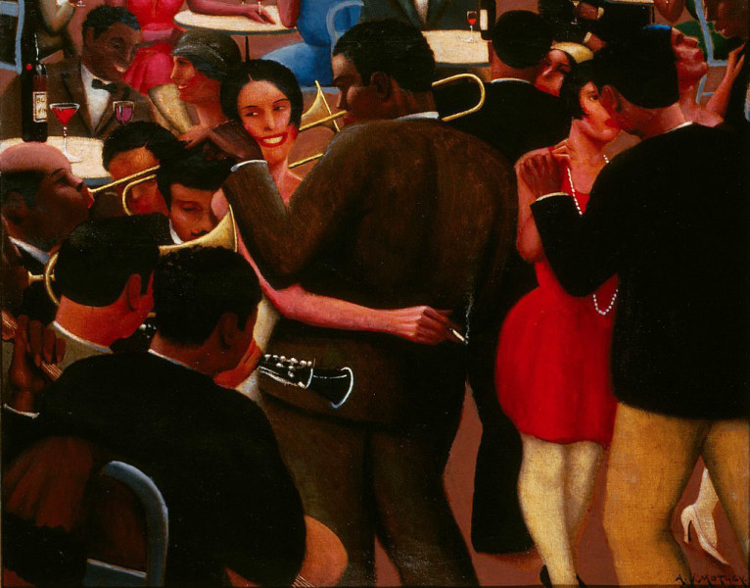

1. In his painting, Blues, what do you think Motley is trying to express about life for African-Americans in the late 1920s?

Source # 3 (Online Video): Louis Armstrong, http://www.youtube.com/watch?v=sIILBeUrYLk
1. What was Armstrong’s influence on the development of music in America?

2. Why is he significant to the study of African-American history?

Source # 4 (Online Video): Bessie Smith, http://www.youtube.com/watch?v=CT4z847-hyc
1. What was Smith’s influence on the development of music in America?

2. Why is she significant to the study of African-American History?

*Discussion Questions: Discuss these questions as a group and share your ideas.
1. How would you complete the following sentence? (It’s okay to have different answers.)
The Harlem Renaissance was…

2. Was it important that African-Americans at this time be able to express themselves through music, art, poetry, etc.? Why?

3. In what ways do African-Americans express their culture now in modern times? Can you give examples?

*Student Generated Questions: Create two discussion questions related to the Harlem Renaissance that you would like to ask your classmates?
1.

2.

