- transduction Transforming signals into neural impulses.
- inattentionalblindness When we are focused on one action so we miss another action.
- bottomup Processing that begins with the sense receptors and works up to the brain’s integration of sensory information.
- subliminal When stimuli are below one’s absolute threshold for conscious awareness
- sensoryadaptation diminished sensitivity as a consequence of constant stimulation
- pupil adjustable opening in the center of the eye.
- iris a ring of muscle that forms the colored portion of the eye
- blindspot point at which the optic nerve leaves the eye
- rods detect black, white and gray
- cones fine detail and color vision
- parallel processing several aspects of a problem simultaneously
- red The opposing retinal color of green is what?
- Kinesthesis the system for sensing the position and movement of individual body parts.
- Gestalt An organized whole
- proximity group nearby figures together
- convergence Binocular cue, two eyes move inward for near objects.
- interpostition A closer object blocks distant object.
- relative higher objects seen as more distant is what kind of height?
- ESP controversial claim that perception can occur apart from sensory input,(Abrv.)
- size smaller image is more distant is an example of relative what?

Sensation and Perception
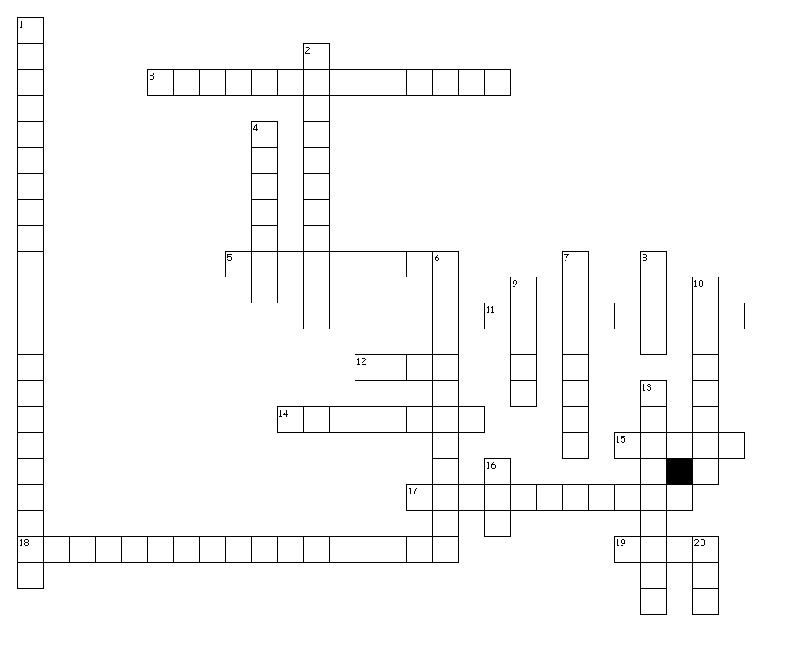
Across
3. A closer object blocks distant object.
5. Point at which the optic nerve leaves the eye
11. When stimuli are below one’s absolute threshold for conscious awareness
12. Detect black, white and gray
14. Processing that begins with the sense receptors and works up to the brain’s integration of sensory information.
15. Fine detail and color vision
17. The system for sensing the position and movement of individual body parts.
18. Diminished sensitivity as a consequence of constant stimulation
19. Smaller image is more distant is an example of relative what?
Down
1. When we are focused on one action so we miss another action.
2. Binocular cue, two eyes move inward for near objects.
4. An organized whole
6. Transforming signals into neural impulses.
7. Higher objects seen as more distant is what kind of height?
8. A ring of muscle that forms the colored portion of the eye
9. Adjustable opening in the center of the eye.
10. Processing several aspects of a problem simultaneously
13. Group nearby figures together
16. The opposing retinal color of green is what?
20. Controversial claim that perception can occur apart from sensory input,(Abrv.)

