1
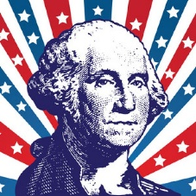
Setting a Precedent- As president and head of the executive branch, Washington was responsible for enforcing the government that the Constitution created. He and the rest of the First Federal Congress quickly realized that the Constitution did not have clear solutions to every problem they would face. The way that Washington and the First Federal Congress handled some of the issues the country faced during his tenure as president created a precedent, or an example for how future presidents should deal with similar situations.

The Cabinet-In order to establish some balance he chose a cabinet with members from different regions in the country. In filling the many offices created by the new government, Washington avoided making appointments based on social standing, heritage, or friendship. His appointments advanced the idea that the best-qualified people should be up for office. Washington rejected management models used by the British. He shoes to delegate his authority to his department heads and closely supervise their actions. His choices were Secretary of State Thomas Jefferson, Secretary of Treasury Alexander Hamilton, and Secretary of War Henry Knox. While the Department of Justice would not be created until 1870, Washington appointed and included the Attorney General Edmund Randolph in his first cabinet.

Hamilton’s financial Plan- #1: Pay off all war debt
- Combine all state debts into a single national debt…$52 million
  - Many Southern states had repaid their debt
- Replace old bonds issued by the national government with new bonds. Paying off all the loans would reestablish the United States’ credit
- #2: Raise government revenue
- Hamilton felt industry (manufacturing) would make economy stronger
  - Proposed a tariff to encourage American products
  - South had little industry & opposed the tariff
- #3: National bank that would serve many purposes
- Bank would give government a safe place to keep money
- Businesses would be helped through loans
- Bank would issue bank notes (paper money used as currency)

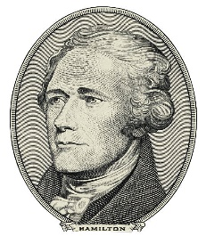
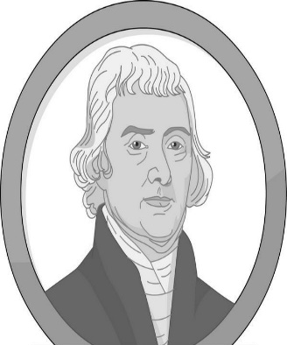
Thomas Jefferson Argued for a strict interpretation of the Constitution. If the Constitution does not mention it, the government cannot do it.
Jefferson would support Hamilton’s financial plan if Hamilton would support moving the nation’s capital to the South
- Created a new Southern capital called City of Washington, District of Columbia

Thomas Jefferson’s Objections

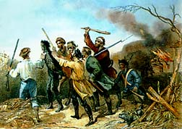
The French
- U.S. caught in middle between war of France and Britain
- Both nations attack our ships on the high seas, doesn’t recognize U.S. freedom of the seas
- British impressment of American sailors

- Why is it important?
- Proved that the federal government under the new Constitution had power
- Washington was willing to use military force to enforce federal law

End of the Rebellion
- Militia breaks up rebellion
- Insurgents arrested
- Washington offers pardons in exchange for oaths of loyalty to the government

The Whiskey Tax
- Hamilton tries to increase revenue for the U.S. Government
- Tax on all distilled spirits passes Congress in 1791

The Whiskey Rebellion
- From Pennsylvania to Georgia western farmers refuse to pay tax
- Tax collectors were attacked

The Proclamation of Neutrality (1790)
Washington issues The Proclamation of Neutrality!
- Washington believed war must be avoided at all costs
- America's first formal declaration proved to be enormously controversial:
- Pro-French Jeffersonian (Democratic-Republicans) enraged
- Pro-British Federalists happy

Jay and Pinkney’s Treaty
Jay’s Treaty meant to avoid war with the British
Trade treaty with Britain
British agreed to leave forts in the Northwest Territory
Still attacking American ships and impressing sailors.
Agreed to end discrimination against American commerce and to grant the U.S. trading privileges in England and the British East Indies
Pinckney’s Treaty
-trade treaty with Spain
Granted:
Free navigation of Mississippi
Warehouse rights at New Orleans
Territory of western Florida
Agreed to control natives in FL while U.S. agreed to control those in GA

