Post-WWII /Cold War America- Domestic Changes & Policies
Introduction
At the end of World War II in 1945, more than 12 million Americans were in the military. Thousands of American factories had been running full speed during the war. Virtually overnight, both the need for such a huge military machine and the focus on war production came to an end. Orders went out from Washington, D.C., cancelling defense contracts, causing millions of defense workers to lose their jobs. Wartime industries had to convert back to meet peace-time needs: consumer goods. Americans were happy that the war was over, but polls in the fall of 1945 showed 60% of Americans expected their incomes to fall as the country moved back to a peace-time economy. Soldiers especially were worried about post-war joblessness. There was fear of another Great Depression.

- What challenges faced Americans after World War II?

Over ten million men and women were released from U.S. military service during the 20 months following the end of World War II. They went home to take up their civilian lives where they had left off, before the war. It soon became obvious to them – and to all Americans – that the postwar years were very different from the prewar years. Before the war, Americans had been struggling with economic depression – with the Dust Bowl, unemployment, and widespread poverty. By 1946, the United States saw more marriages than any other year in history. With the aid of the GI Bill, most GIs found their way into colleges, trade schools, or jobs within a few months of returning home. The feared depression following WWII did not occur. In fact, most Americans enjoyed prosperity and economic opportunities like never before. Marriages, growing families, a housing boom in the suburbs, widespread ownership of autos and televisions, the advent of fast food chains – these and much more marked the decade just after the war.

- Describe the United States in the decade following the end of World War II.

TRUMAN (1945-1953)

The GI Bill Aids Returning Soldiers
To help deal with post-war economic anxiety, the federal government enacted a law called the Servicemen's Readjustment Act of 1944, popularly known as the GI Bill of Rights. It granted veterans a variety of benefits. It provided a year of unemployment payments to veterans who were unable to find work. Those who attended college after the war received financial aid of $500 per year for college tuition. The bill also provided $50 a month for living expenses and $75 a month for married couples. The act also entitled veterans to government loans for building homes and starting businesses. The GI Bill had enormous impacts on American society. Home loans to veterans fueled an upsurge in home construction, which led to the explosion of suburbia.

- Describe three ways the GI Bill impacted veterans of World War II.

- What greater impact did the GI Bill have?

A Baby Boom Fills Classrooms
Upon their return, soldiers quickly made up for lost time by marrying and having children. Americans put off having children because of the depression and WWII. Now, confident that the bad times were behind them, many married couples started having families. This led to what became known as the baby boom. In 1957, at the peak of the baby boom, one American baby was born every 7 seconds, a grand total of 4.3 million for the year. One newspaper columnist commented, “Just imagine how much these extra people will absorb in food, clothing, in gadgets, in housing, in services.” Between 1940 and 1955, the U.S. population experienced its greatest increase, growing 27% from about 130 million to 165 million.

- Why was there a baby boom after World War II?

- Prediction: Based on the newspaper columnist’s comment, what do you think the economy will be like in the decades following World War II?

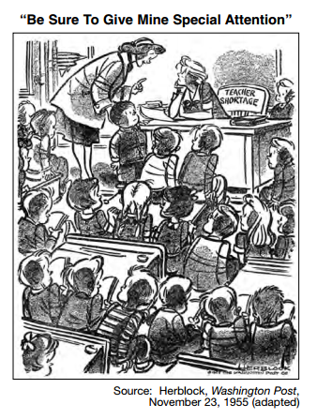
- What is the main idea of the cartoon to the right?

EISENHOWER (1953-1961)

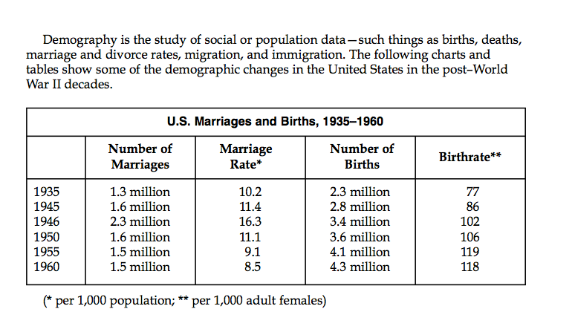

- How did the demographics of the United States change after World War II? How can you connect the GI Bill to these demographic changes?

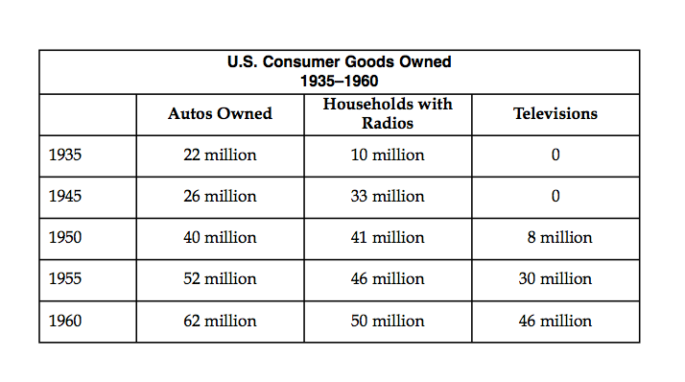

- What impact did the baby boom have on American society in the decades following World War II?

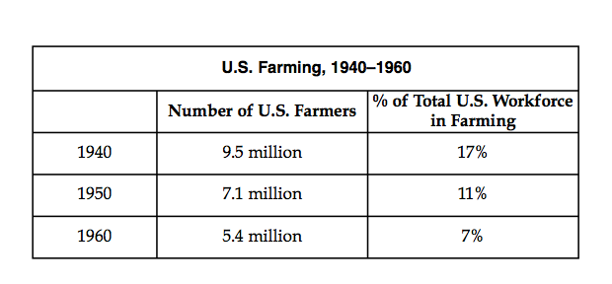

- How did the demographics change, according to this chart?

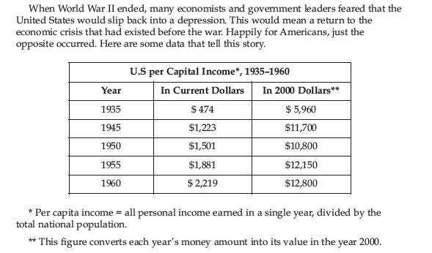

- Describe the economic changes that occurred in post-war America.
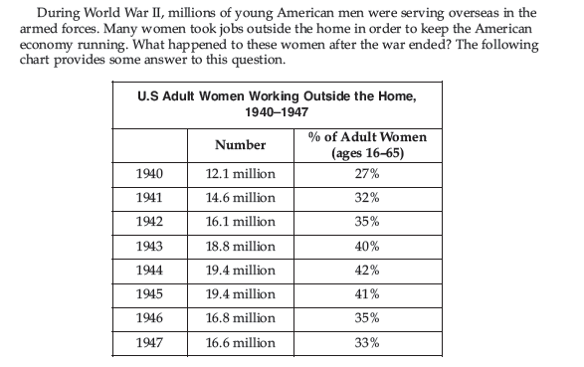

- How did the lives of American women change after the war?
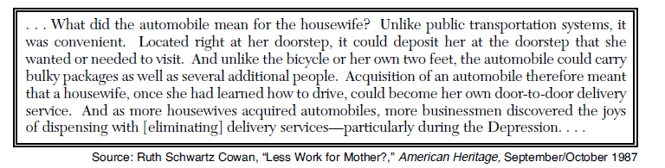

13. According to this document, how did women’s lives change after the war?

Interstate Highway Act
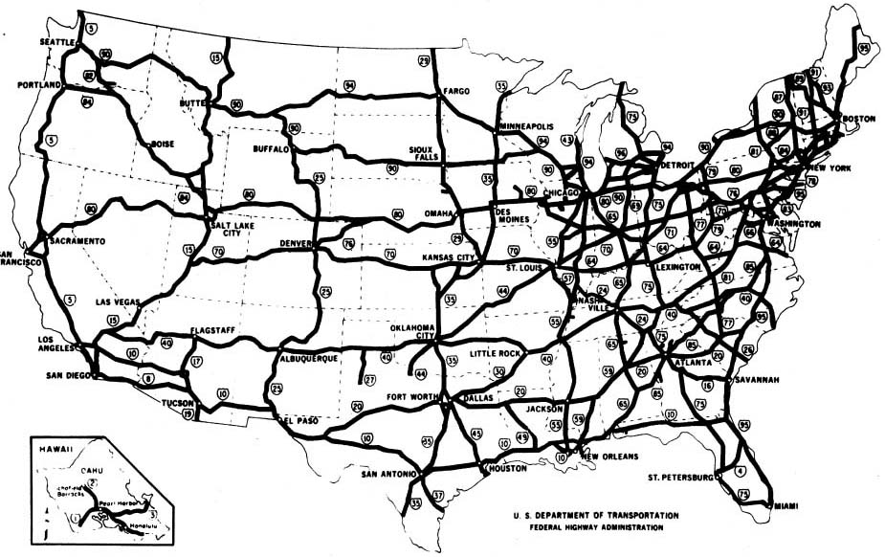
In 1956, the Interstate Highway Act authorized funds to build 41,000 miles of highway consisting of multi-lane expressways that would connect the nation’s major cities. The system became known as the Dwight D. Eisenhower System of Interstate and Defense Highways.

When the American Association of State Highway Officials (AASHO) issued design standards for the Interstate System, the minimum design value of 14 feet was included for vertical clearance. Although 14 feet was sufficient for civilian needs, the Department of Defense informed the U.S. Bureau of Public Roads, which had adopted the AASHO design standards, that a vertical clearance of 17 feet was needed for defense purposes on the National System of Interstate and Defense Highways.

14. What do you think the purpose(s) of the Interstate Highway Act?

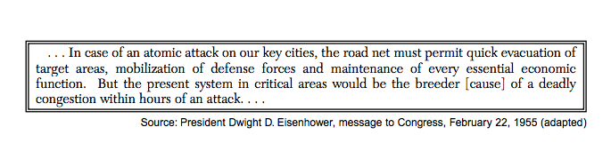

- How does Eisenhower justify an interstate highway system?
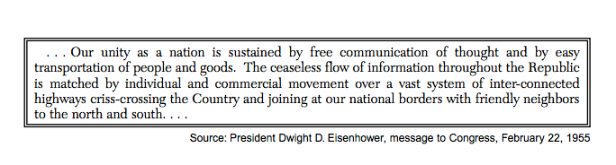

16. After reading these several documents on the Interstate Highway System, why do you think Congress authorized the funding of such a vast public works project? Make sure you consider the context of history at this time. In other words, what was going on in history at this particular moment?

17. As we have already discussed, the Interstate Highway Act had military and economic goals: to move weapons across the country as needed during the Cold War and to move consumer goods across the country. What other impact might this have on American society? Use the pictures on the next page as hints.

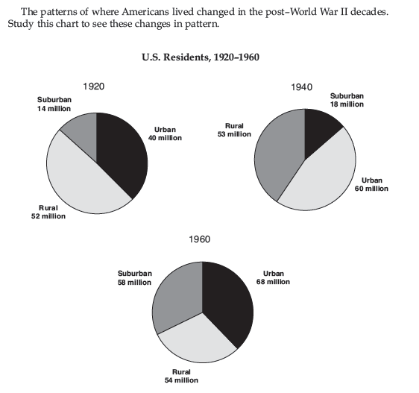

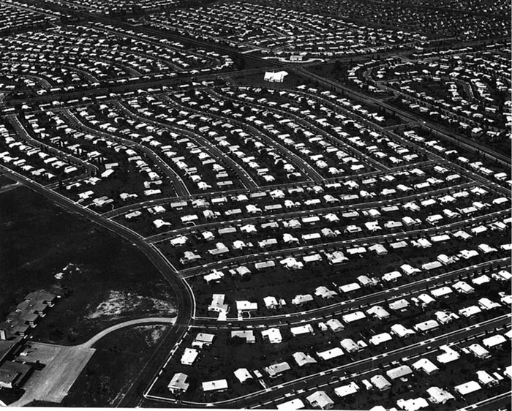
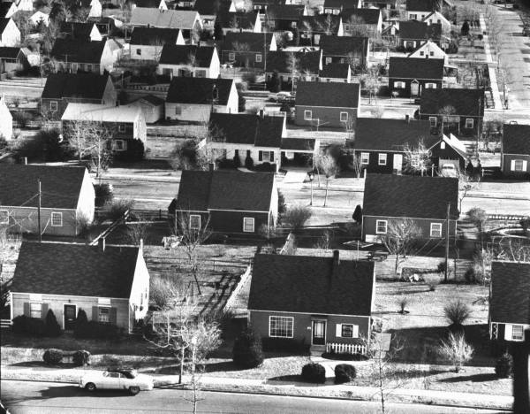

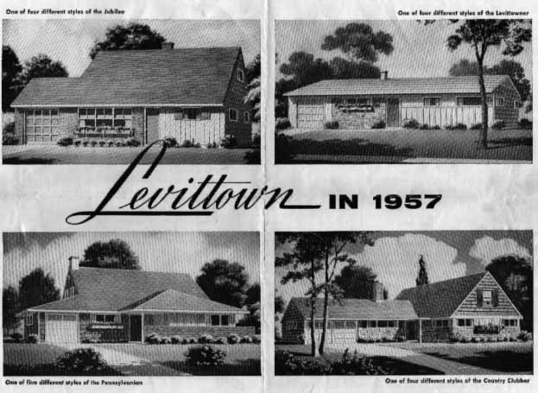
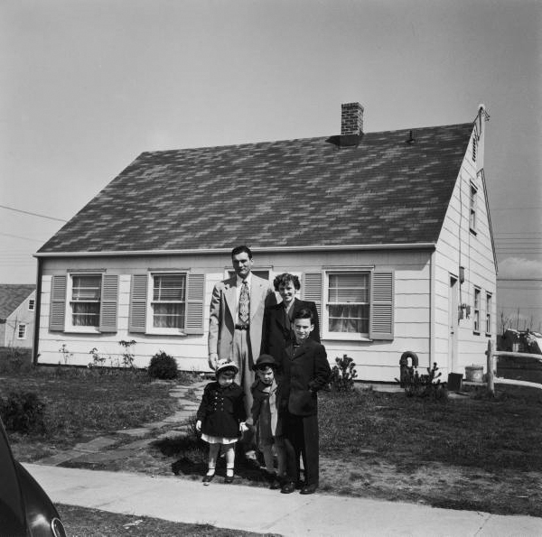

“…They came to own their own home, cook with their own appliances and mow their own lawns. They had GI loans in hand, babies on the way, and a ‘50s brand of pioneering spirit…”

“We were young, all of us who moved to Levittown, and we thought Bill Levitt was the greatest man in the world. Imagine it - $10 deposit, $90 settlement, and you had a house of your own!”
-Jon Blackwell

- How did patterns of living change after World War II? What factors do you think contributed to this?

- What are “Levittowns”?

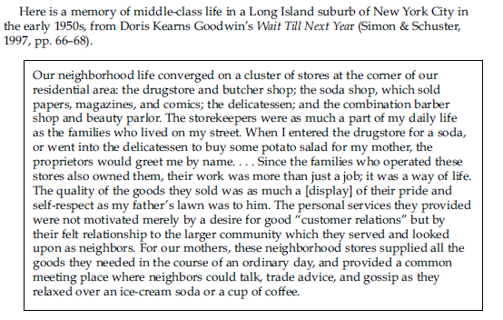
- How does Doris Kearns describe suburban life?

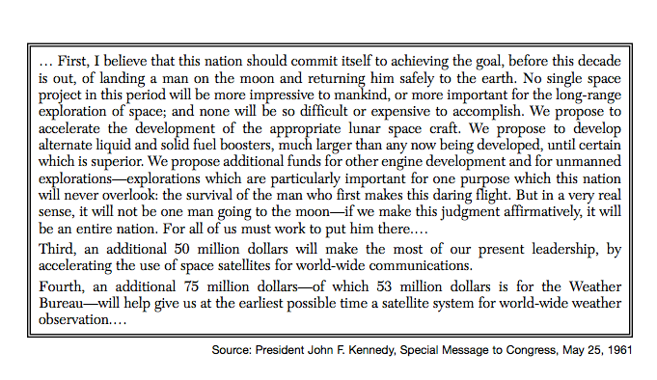
KENNEDY (1961-1963)

- What is Kennedy’s goal by the end of the Sixties?

- Besides landing on the moon, what other motives down Kennedy have for the “space race”?

- How might this change education in the United States?

SUMMARY QUESTION

How did the United States change after World War II during the Cold War (1945-1960s)? Make sure to include information from all three presidents discussed here (Truman, Eisenhower, and Kennedy)

