Literacy Groups: Influential African-Americans of the Early 20th Century
“Booker T. Washington, W.E.B. Du Bois, and George Washington Carver”
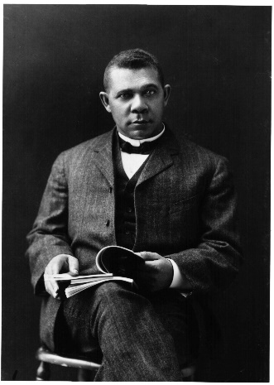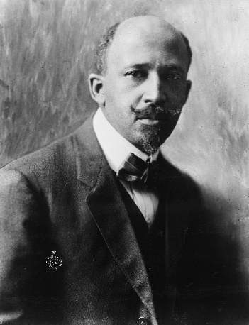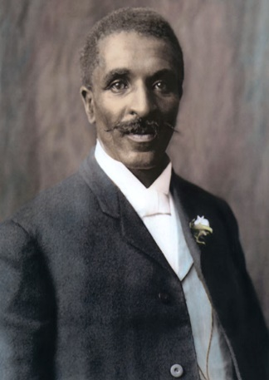
Instructions: Watch the video(s) and read the text(s), then discuss and answer the questions as a group. You will find the video and text on the website. Write down your responses on this sheet and keep it in your notebook for grading. Be prepared to share your answers and ideas.

Source # 1 (Online Article): Booker T. Washington Bio, http://www.history.com/topics/black-history/booker-t-washington
1. Why did Washington found the Tuskegee Institute in 1881?

2. How do you think his background helped to shape his views as a leader of the black community?

3. Washington supported ‘racial accomodationism’. What is ‘racial accomodation’ and why do you think he supported it?

4. In summary, why is Booker T. Washington important to African-American Studies?

5. Develop one discussion question you would like to ask your classmates about Washington?

Source # 2 (Online Article): W.E.B. Du Bois Bio, http://www.pbs.org/wnet/jimcrow/stories_people_dubois.html
1. Du Bois once stated, “Education must not simply teach work – it must teach life.” Can you explain why you think he made this statement?

2. Can you compare and contrast Du Bois views on how to overcome racial discrimination with Booker T. Washington’s views? Which view do you tend to agree with? Why?

3. In summary, why is Du Bois important to African American Studies?

4. Create one discussion question you would like to ask your classmates about Du Bois?

Source # 3 (Online Video): George Washington Carver Bio, http://www.youtube.com/watch?v=sdz8XTNttdc
1. In what ways did Carver contribute to the African American Community?

2. In summary, why is George Washington Carver important to African American Studies?

3. Create one discussion question about Carver that you would like to ask your classmates?

