Harlem Renaissance Assignment
EQ: How did African-American history, including slavery and discrimination, shape African-American communal life and cultural expression? How was the African-American community defined?
Complete all four following parts:

Part I- Read the poem “Harlem” below and answer the guided questions.
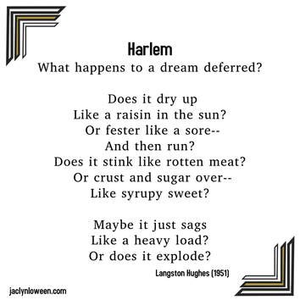

- This poem is about Langston Hughes’ community in Harlem. What impression do you get of Hughes’ community in this poem?

2. Based on this poem, do you think life in Hughes’ community is easy or hard? Why?

3. Why do you think Hughes titled this poem “Harlem: A Dream Deferred”?

4. Do you think this poem could be used to describe your community today? Why or why not?

Part II- Read the Background Information Regarding Langston Hughes
One of the leading voices of the African American artistic community of the 1920s, Langston Hughes was a member of the “Harlem Renaissance.” The Harlem Renaissance was the flowering of art and intellectual life during the 1920s and 1930s in Harlem, the part of New York City in which many African Americans resided. Hughes focused his writing on the realistic plight of African Americans. He authored more than 50 literary works covering all genres: poetry, fiction, autobiography, children’s books, opera, and drama.
In his early years, Hughes was greatly influenced by W. E. B. DuBois and his grandmother’s stories about his grandfather, who took part in John Brown’s raid on Harper’s Ferry in 1859 to arm the slaves.

Hughes attended Columbia University in New York City, dropping out in the early 1920s to “see the world.” After returning to the United States, he won a scholarship to Lincoln University in Pennsylvania (graduating in 1929), where he was considered one of the most promising young poets of his generation.
A friend of Ernest Hemingway, Hughes continued to travel widely and made Harlem his permanent home in 1942.
Hughes, unlike many of the Harlem Renaissance writers, was able to support himself financially through his writing. His works included “Simple Speaks His Mind,” featuring the witty and ironic street-smart Harlem resident who commented on the everyday life of African Americans. His well-known poems, such as “The Negro Speaks of Rivers,” “The Weary Blues,” and “Harlem,” were meant to be read aloud; due to his use of rhythmical language, the poems were frequently set to music in order to actively engage the audience. Hughes also had success on Broadway where his 1935 play “The Mulatto” became a hit.

Part III- Complete the Harlem Renaissance to Hip HOP Assignment. Read the poem “I, too” and the lyric to the song “Changes” by Tupac Shakur and complete the handout. Assignment is attached.

Part IV- Conclusion: Connection to Martin Luther King: Students will complete the following writing prompt:
In 1963, Martin Luther King gave his famous “I Have a Dream” speech in front of the Lincoln Memorial in Washington, DC. This speech can be found at: http://www.americanrhetoric.com/speeches/mlkihaveadream.htm
Read the speech and respond to the following prompt in no more than 2 paragraphs:
What dreams do you think Martin Luther King had for his community? Do you think Martin Luther King’s dreams were similar or different from Langston Hughes’s dreams? What dreams do you have for your community? Are your dreams similar or different from those of Langston Hughes or Martin Luther King? Why? Can dreams become reality? How? Can artists play a role in making dreams into reality?

