Name: __________________________ Date: ___________

Honors Psychology Mrs. Reid

EYE WEB QUEST

You will learn about the eye by completing the following webquest. READ and FOLLOW all instructions listed below in the order they appear.

Purpose: To deepen the understanding of how the eye functions and how it utilizes light.

**Part 1: What is an Eye?**

**Instructions:**

**1) Go to the following website:** [**http://www.myeyeworld.com/files/eye_structure.htm**](http://www.myeyeworld.com/files/eye_structure.htm)

**List the FUNCTION of each of the parts of the eye:**

**a) lens:**

**b) cornea:**

**c) retina:**

**d) pupil:**

**e) iris:**

**f) sclera:**

**g) optic nerve:**

**h) ciliary body (muscle):**

2) Go to the following websites below. You will find a flash animation that will help you to understand the operation of the eye. When you complete them all, label the diagram below.

Flash animation 1-Eye Structure and Function

<http://www.kscience.co.uk/animations/eye_function_drag.htm>

Flash animation 2- Eye Structure

<http://www.kscience.co.uk/animations/eye_drag.htm>

Flash 3- structure

<http://www.kscience.co.uk/animations/eye.htm>



Labels the parts of the eye and their functions onto the diagram:

a) PARTS:

Optic nerve

retina

lens

cornea

sclera

iris

ciliary bodies

pupil

b) FUNCTIONS:

Focuses light onto retina

transparent and focuses light

Tough outer coat

Changes size to control light

Gap that light passes through

Carries impulse to brain

Contracts to change lens shape

Contains light receptor cells

**Part 2: What is Vision?**

1. **Go to the following website: http://kidshealth.org/en/kids/eyes.html**

**As you read through the information about your eyes, find 3 important items to know about your eyes from each reading section.**

[“Your Eyes”.](http://kidshealth.org/kid/htbw/eyes.html)

Big As a Ping Pong Ball:

a.

b.

c.

Iris Is The Colorful Part:

a.

b.

c.

Light, Lens, Action:

a.

b.

c.

A Muscle Makes It Work:

a.

b.

c.

Rods and Cones Process Light:

a.

b.

c.

Helping You See It All:

a.

b.

c.

To the Brain!:

a.

b.

c.

Have No Fear, You Have Tears:

a.

b.

c.

### ****Part 3:**** Eye Disorders

1) Go to the following website: <http://camillasenior.homestead.com/optics4.html>

2) Answer the following questions below:

1. How is light focused when someone is nearsighted? What kind of lens is used to correct this?
2. How is light focused when someone is farsighted? What kind of lens is used to correct this?
3. When a person looks at an object, what position is the object in when it hits the retina?
4. Where is the message of the object sent to after it hits the retina? What part of the eye ships the information there?

Name: __________________________ Date: ___________

Honors Psychology Mrs. Reid

Ear Web Quest

<http://www.physicsclassroom.com/class/sound/u11l2d.cfm>

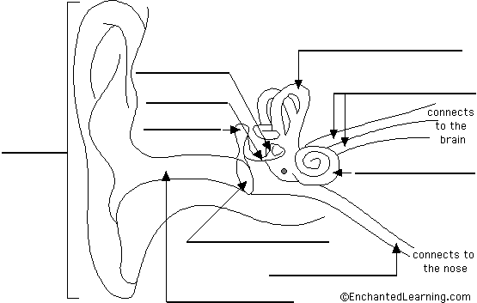

1. Label the parts of the ear above.
2. Explain how sound travels from a source to when it’s being interpreted by the brain.
3. State the function of the: Pinna, Eardrum, Ossicles, Cochlea Auditory Nerve and the Brain.

Extra Information:

An eye is a round-shaped organ that works with the brain to provide us with vision. The shape of the eye is maintained by the pressure of the aqueous humor. The aqueous humor is the fluid that fills the front chamber of the eye.

**Function of the Eye**

The main function of the eye is to work with the brain to provide us with vision. The eye and brain translate light waves into a sensation we call vision.

**Eye Parts**

The eye has many parts. Some of the main parts are listed and described below.

* lens
  + The transparent crystalline lens of the eye is located immediately behind the iris.
* cornea
  + The cornea is a transparent dome which serves as the outer window of the eye. The cornea is the most powerful structure focusing light entering the eye.
* retina
  + The retina is the innermost layer of the eye. It is composed of nerve tissue which senses the light entering the eye.
  + The retina sends impulses through the optic nerve back to the brain, which translates the impulses into images that we see.
  + There are 4 types of light-sensitive receptors found in the retina
    1. rods
    2. cones that absorb long-wavelength light (red)
    3. cones that absorb middle-wavelength light (green)
    4. cones that absorb short-wavelength light (blue)
* pupil
  + The pupil is the hole in the center of the eye where light passes through.
* iris
  + The iris is the colored part of the eye. It is a thin diaphragm composed mostly of connective tissue and smooth muscle fibers. The iris lies between the cornea and the crystalline lens.
* optic nerve
  + The optic nerve is a continuation of the axons of the ganglion cells in the retina. It acts like a cable connecting the eye with the brain.
  + The optic nerve is also called the cranial nerve II.
* sclera
  + The sclera is the white, opaque portion of the eye. It provides protection and serves as an attachment for the extra ocular muscles which move the eye.