American History II | Unit 1 – The Great West and the Gilded Age
Economics, Race, and the Populist Party
Economic Turmoil of the 1870s
The Panic of 1873 |  |  | Currency Dispute
Farmers Unite to Address Common Problems
Economic Distress |  |  | The Grange
Problems with the Railroads |  |  | The Farmers’ Alliances
Grangers Begin to Make Progress
Munn v. Illinois (1876)
Wabash v. Illinois (1886)

Political Parties of the 1890s
Democratic Party |  | Populist Party |  | Republican Party
 |  | “Fusion” Coalition
Gold Bugs and Silverites
 | Gold Bugs |  | Silverites (Bimetallists)
Who They Were
What They Wanted
Why
Effects | ___FLATION |  | ___FLATION
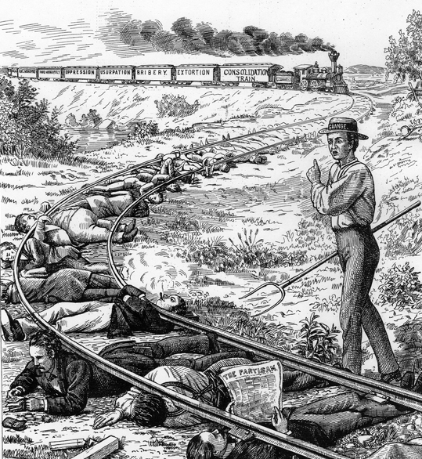
“The Plight of the Farmers”
1. What is happening to the “ordinary” people in the cartoon?
2. Who is the “hero” of the cartoon, warning the people of the coming danger?
3. Who does the cartoonist suggest is responsible for the farmers’
4. What are the weapons of the famers’ dangerous enemy?
The Wilmington Race Riot of 1898
Directions: Respond to the following questions on a separate sheet of paper. When you have finished, staple your responses to your notes page.
1. Why was Wilmington, NC considered a symbol of “black hope” at the end of the 19th century?
2. What tactics did white Democrats use to break the alliance of the black and white “Fusion” Coalition in efforts to win the 1898 campaign?
3. What role did the media and propaganda play in the 1898 Wilmington Race Riot?
4. Who were the Red Shirts and what “scare tactics” did they use to affect the 1898 campaign?
5. Summarize the four-pronged plan that occurred in Wilmington, NC.
6. Summarize the aftermath of events in Wilmington. Out of the various types of injustice the African American community experienced. What do you think would have been most difficult to deal with and why?
7. Why is it important to study this period of history today, even though it might be difficult to hear based on the racism, violence, and calculated cruelty that was at play?

