Causes of the Civil War DBQ - Documents

Document 1:

Excerpt from a speech by Albert Gallatin Brown, a Mississippi politician
September 26, 1860
(The Northerners) hate us now, and they teach their children in their schools and churches to hate our children...the John Brown raid...the abolitionists among us, tell the tale...The North is accumulating power, and it means to use that power to emancipate (free) your slaves...Disunion is a fearful thing, but emancipation is worse. Better leave the union in the open face of day, than be lighted from it at midnight by the arsonist's torch."

Questions Document 1:
- What was John Browns raid and what effect did it have on relationships between Northerners and Southerners?
- What actions does Albert Gallatin Brown believe the South needs to take and why?

Document 2:

Excerpt from Dred Scott v. Sanford, Supreme Court decision, 1857
...upon full and carefull consideration of the subject, the court is of the opinion, that, upon the facts stated...Dred Scott was not a citizen of Missouri within the meaning of the constitution of the United States and note entitled as such to sue in its courts.

Questions Document 2:
- What was the outcome of Dred Scott v. Sanford?
- What Compromise did this case go against; explain the original provisions of Compromise?
- What is the significance of this decision?

Document 3:

HISTORICAL BACKGROUND:
Harriet Beecher Stowe published the best-selling antislavery novel, Uncle Tom's Cabin, in 1852. She wrote this book to show that slavery was evil and that the Fugitive Slave Law was unjust. Many Northerners viewed slavery as wrong. Abolitionists wanted to end slavery and some helped slaves escape to the North and Canada. The Southerner's believed that they were stealing their property.
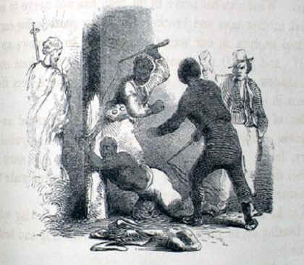
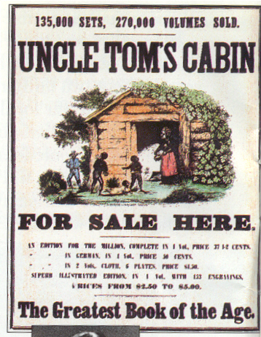
Simon Legree beating Tom
from Uncle Tom's Cabin by Harriet Beecher Stowe, 1852

In March 1862, Harriet Beecher Stowe visited the White House and upon meeting President Abraham Lincoln, said, "So this is the little lady who made this big war?"
Questions Document 3:
- What did this book reveal? Why is it significant?

Document 4:
HISTORICAL BACKGROUND:
November 6, 1860 - Abraham Lincoln, who had declared "Government cannot endure permanently half slave, half free..." is elected president.
Dec 20, 1860 - South Carolina secedes from the Union. Followed within two months by Mississippi, Florida, Alabama, Georgia, Louisiana and Texas. Seven states of the Deep South, those in which the slavery system is most entrenched, leave the Union. Many Southerners favored secession as part of the idea that the states have rights and powers which the federal government cannot legally deny. The supporters of states' rights held that the national government was a league of independent states, any of which had the right to secede.
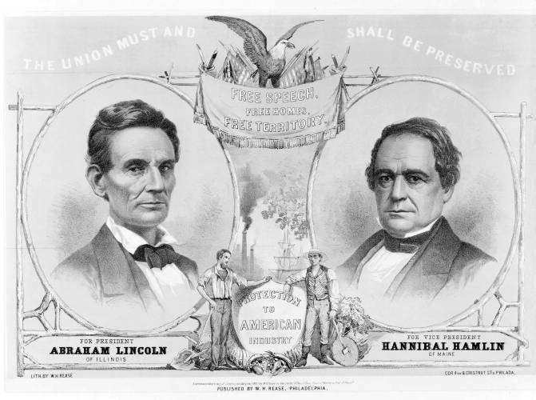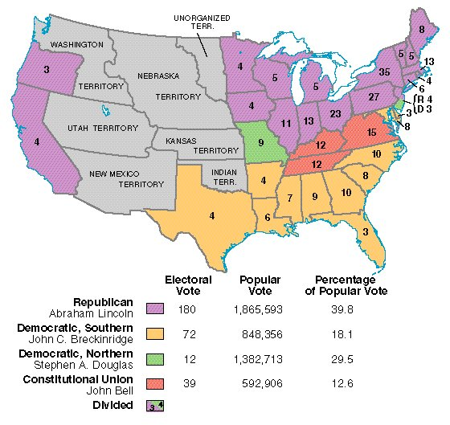
Questions Document 4:
- Draw three conclusions from the map and data on the election of 1860.
- Lincoln’s quote states his view on sectionalism and secession, why is this important and what is his view on the matter?
Document 5:
HISTORICAL BACKGROUND:
"The sectional division between North and South began in colonial times and resulted from geographical differences. In the South, the earliest settlers found the warm climate and fertile soil ideal for growing tobacco. They started many tobacco plantations and brought in black slaves from Africa to provide most of the labor. In time, other plantation crops, especially cotton, sugar cane, and sugar beets, were found to thrive in the South. The South thus quickly established a rural way of life supported by an agricultural economy based on slave labor.
The cooler climate and rocky soil in the North were not suitable for establishing plantations or large farms. As a result of those and other factors, the North's economy came to depend more on trade than on agriculture. Industry and commerce were centered in the North. Many factories using mass-production methods had sprung up there, and cities grew rapidly." The North developed an intricate railway system and shipping industry to transport the manufactured goods.
Source: A-Z History http://school.discovery.com/homeworkhelp/worldbook/atozhistory/c/HEAD1
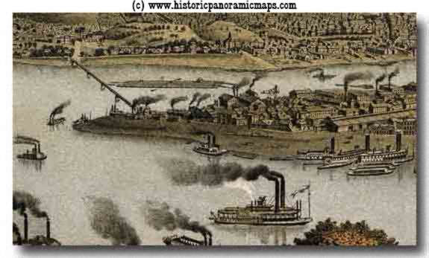
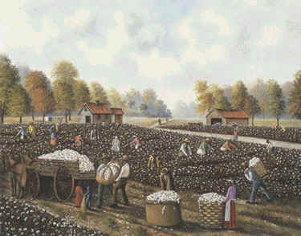

Southern Cotton Plantation 1850s Pittsburgh Factories 1850s
Questions Document 5:
- What are the differences in these two pictures? What do they tell about the two economies of the divided U.S.? Use specific examples to support your answer.

Document 6:
Declarations of Causes of Seceding States South Carolina
Declaration of the Immediate Causes Which Induce and Justify the Secession of South Carolina from the Federal Union
Excerpts written by C. G. Memminger
In pursuance of this Declaration of Independence, each of the thirteen States proceeded to exercise its separate sovereignty; adopted for itself a Constitution, and appointed officers for the administration of government in all its departments-- Legislative, Executive and Judicial. For purposes of defense, they united their arms and their counsels; and, in 1778, they entered into a League known as the Articles of Confederation, whereby they agreed to entrust the administration of their external relations to a common agent, known as the Congress of the United States, expressly declaring, in the first Article "that each State retains its sovereignty, freedom and independence, and every power, jurisdiction and right which is not, by this Confederation, expressly delegated to the United States in Congress assembled."

We, therefore, the People of South Carolina, by our delegates in Convention assembled, appealing to the Supreme Judge of the world for the rectitude of our intentions, have solemnly declared that the Union heretofore existing between this State and the other States of North America, is dissolved, and that the State of South Carolina has resumed her position among the nations of the world, as a separate and independent State; with full power to levy war, conclude peace, contract alliances, establish commerce, and to do all other acts and things which independent States may of right do.
Adopted December 24, 1860

Sources: Library of Congress
J.A. May & J.R. Faunt, South Carolina Secedes (U. of S. Car. Pr, 1960), pp. 76-81

Jefferson Davis, Message to the Confederate Congress (April 29, 1861)

“It was by the delegates chosen by the several States… that the Constitution of the United States was framed in 1787 and submitted to the several States for ratification… [These] States endeavored in every possible form to exclude the idea that the separate and independent sovereignty of each State was merged into one common government and nation, and… to impress on the Constitution its true character – that of a compact between independent States.

… Amendments were added to the Constitution placing beyond any pretense of doubt the reservation by the States of all their sovereign rights and powers not expressly delegated to the United States by the Constitution.

Strange, indeed, … [the Constitution has] proved unavailing to prevent the rise and growth in the Northern States of a political school which has persistently claimed that the government thus formed was not a compact between States, but was in effect national government, set up above and over the States.”

Questions Document 6:
- What does it mean to secede? What was South Carolina’s reason to secede?
- Who is Jefferson Davis? What is the main reason Davis claims the government is going against the Constitution?

Document 7:
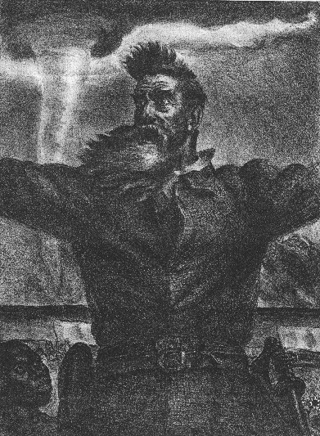
JOHN BROWN'S LAST SPEECH
November 2, 1859
(American State Trials, ed. by J. D. Lawson, Vol. VI, p. 800 ff.)
John Brown, most fanatical of abolitionists, planned to incite a general insurrection of slaves in Virginia and form a free state somewhere in the mountains of western Maryland and Virginia. With the aid of funds gathered in New England and New York he collected supplies and arms at a farmhouse near Harper's Ferry, Virginia, and on the night of October 16 moved on the town of Harper's Ferry and captured the government armory. United States marines under the command of Col. R. E. Lee carried the armory by assault, and captured Brown and some of his followers. He was indicted for treason and for conspiring with slaves to commit murder, convicted, and sentenced to be hanged. On Brown, see 0. G. Villard, John Brown; F. B. Sanborn, Life end Letters of John Brown; R. P. Warren, John Brown. The trial is given in full in American State Trials, Vol. VI.

I have, may it please the Court, a few words to say.

In the first place, I deny everything but what I have all along admitted,—the design on my part to free the slaves. I intended certainly to have made a clean thing of that matter, as I did last winter, when I went into Missouri and there took slaves without the snapping of a gun on either side, moved them through the country, and finally left them in Canada. I designed to have done the same thing again, on a larger scale. That was all I intended. I never did intend murder, or treason, or the destruction of property, or to excite or incite slaves to rebellion, or to make insurrection.
Questions Document 7:
- What actions did Brown take towards slavery?
- What event is he most known for?
- How was John Brown viewed-describe at least two perspectives?
Document 8: “Cotton is King,” a speech given by James Henry Hammond on March 4, 1858.
…It appears, by going to the report of the Secretary of Treasury, which are authentic, that last year the United States exported in round numbers $279,000,000 worth of domestic produce, excluding gold and foreign merchandise re-exported. Of this amount $158,000,000 worth is the clear produce of the South; articles that are not and cannot be made at the North. There are then $80,000,000 worth of exports of products of the forest, provisions and breadstuffs. If we assume that the South made but one third of these, and I think that is a low calculation, our exports were $185,000,000, leaving to the North less than $95,000,000.
In addition to this, we sent to the North $30,000,000 worth of cotton, which is not counted in the exports. We sent to her $7 of $8,000,000 worth of tobacco, which is not counted in the exports. We sent naval stores, lumber, rice, and many other minor articles. There is no doubt that we sent to the North $40,000,000 in addition; but suppose the amount to be $35,000,000, it will give us a surplus production of $220,000,000. But the recorded exports of the South now are greater than the whole exports of the United States in any year before 1856. They are greater than the whole average exports of the United States for the last twelve years, including the two extraordinary years of 1856 and 1857….
With an export of $220,000,000 under the present tariff, the South organized separately would have $40,000,000 of revenue. With one-fourth the present tariff, she would have a revenue with the present tariff adequate to all her wants, for the South would never go to war; she would never need an army or a navy, beyond a few garrisons on the frontiers and a few revenue cutters….
No, you dare not make war on cotton. No power on earth dares to make war upon it. Cotton is king….
Questions Document 8:
- What role did cotton play in the war? Why did it have the name “King”?
- What impact does tax on this perspectives’ life? Why is this significant?
- What perspective do the monetary statistics support? Explain.

Document 9: Cotton Exports as Percentage of All U.S. Exports, 1800-1860.
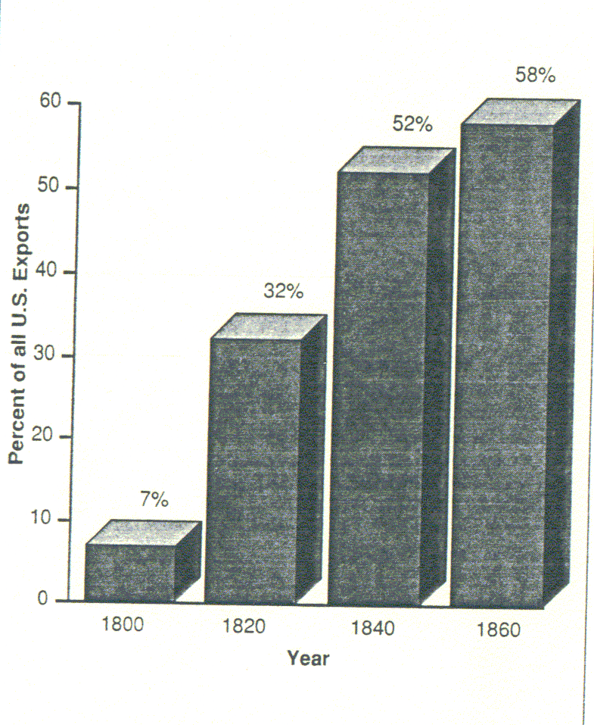

Questions Document 9:
- What does this graph represent from 1800-1860? What is the significance in the percentages-what factors does it tell us about our economy during this time-be specific!?

Document 10:

Compromise of 1850

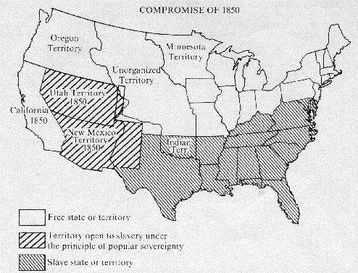

Questions Document 10:
- What was the Compromise of 1850?
- What conclusions can you draw from the map about the United States at this time?

Document 11:
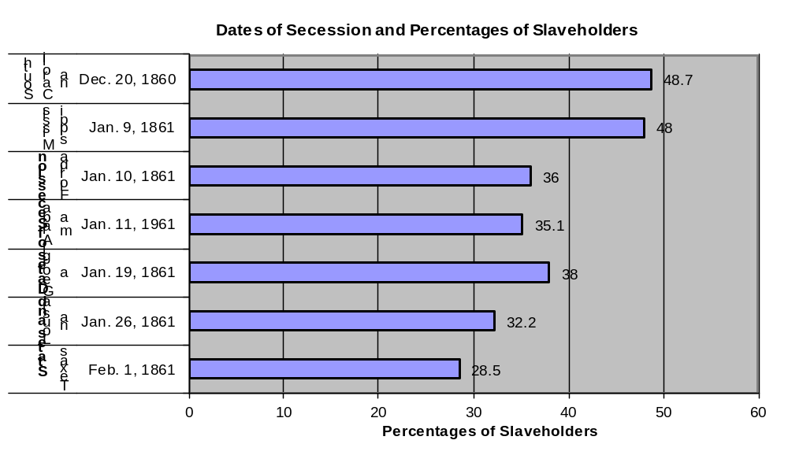
Questions Document 11:
- What is the correlation between order of the states succession and the amount of slaveholders? Explain in detail.
- Who was the first state to succeed and why prior event supports their strong view of states rights?

Document 12: 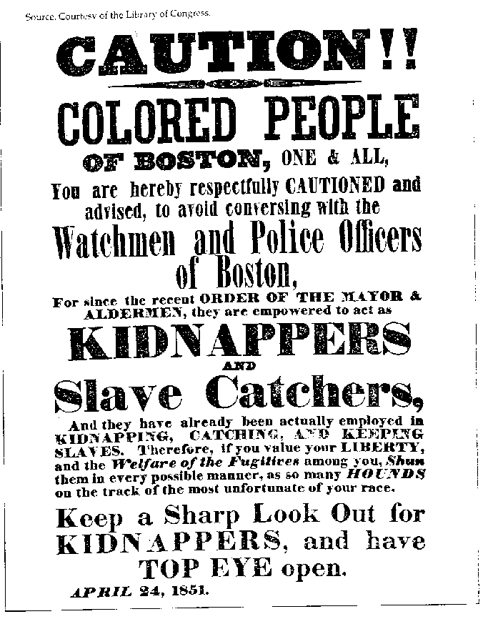
- What Act is this sign referring to? Explain the provisions and implications of this act?
- Does the Act favor one perspective (North or South) over another? Why or why not?
- What perspective is the sign written from?

