Was George H.W Bush (Bush Sr.) a Good President?
Give him a grade
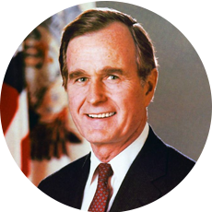

Foreign Policy
Objectives:
Describe how President George H.W Bush Came to Power; Analyze why George H.W Bush decided to use force in some foreign disputes; Summarize the Persian Gulf War and its result

Directions: Using the Documents and your knowledge of the Era, answer the questions and give President George H.W Bush a grade as a President

Document A: George H.W.Bush Becomes President

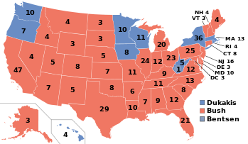
Ronald Reagan used his personal popularity to promote George H.W Bush, his Vice President for eight years, as Bush campaigned for the presidency against Massachusetts governor Michael Dukakis in 1988. Bush called for a “kinder, gentler motion,” yet both candidates attacked the other using negative campaign ads. Bush cemented his support among conservatives by promising not to raise taxes and by casting himself as a defender of traditional values. However, Democrats won a majority of seats in both houses of Congress.
President Bush sought to control federal spending by encouraging Americans to volunteer. Government, he asserted, could take a smaller role in daily life, if, “like a thousand points of light”, community organizations and volunteers provided more help to the disabled, illiterate, and poor.
A graduate of Yale and a veteran of World War II, Bush had served as the US Ambassador the United Nations, as director of the CIA, and as Reagan’s Vice President. His experience would put him to the test as American faced a series of difficult international Affairs.

Directions: Watch the 1988 Political campaign Ads at: https://www.youtube.com/watch?v=u_f8P4OStPc

Questions: Overall Was Bush’s Presidency Successful? Why or Why not?

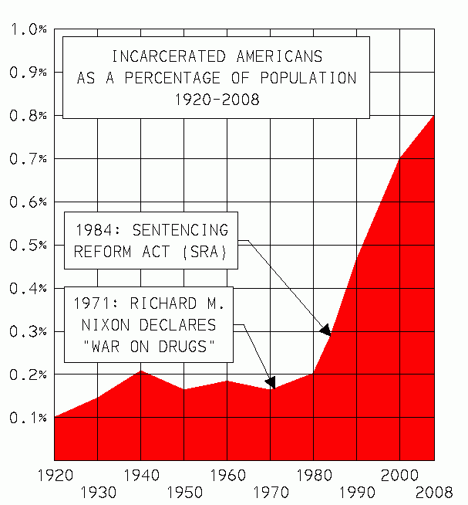
Document B: Latin America and the War on Drugs

In the late 1980s and early 1990s, Latin America experienced a wave of democracy. In Central America, a peace plan devised by Costa Rican leader Oscar Arias brought free elections in Nicaragua and the end of a long civil war in El Salvador. In Chile, the notorious military dictator Augusto Pinochet gave up power.
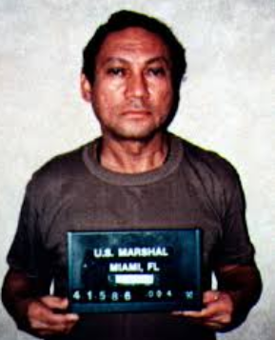
Not all developments in Latin America, however, pleased the Bush administration. Since, the Nixon administration, the government had been waging a “war on drugs”, or an attempt to stop illegal drug use by going after both sellers and users. Groups of racketeers in Latin America supplied a significant amount of the illegal drugs in the United States. The Bush administration arrested and tried several international drug figures, including Eduardo Martinez Romero, the reputed financer of a Columbian drug cartel. Even more spectacularly, in December 1989, Bush sent more than 12,000 US troops to invade Panama and arrest Panama’s Dictator Manuel Noriega. Brought to the United States for trial, Noriega was convicted of several charges of drug trafficking and sentenced to 40 years in prison.

Directions: Watch George HW Bush’s Speech on Drug Wars:
https://www.youtube.com/watch?v=heTB8gcwwuk. What does he want to do? How?

Questions: Overall Was Bush’s Presidency Successful? Why or Why not?

Document C: China Cracks Down on Critics

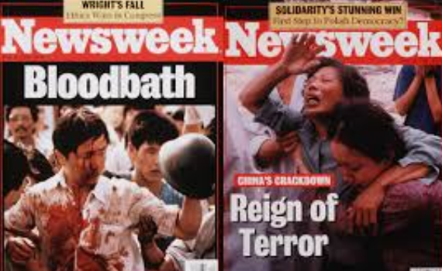
Meanwhile, in the spring of 1989, Chinese students captured the world’s attention by staging prodemocracy protests in Tiananmen Square in the heart of Beijing. Many Americans hoped that these protests might result in the fall of communism in China. Instead, on June 4, Chinese tanks rolled into Beijing, killed hundreds of protesters, crushed the demonstrations, and imprisoned many pro-democracy activists.

The Bush administration condemned this action and suspended arms sales to China. However, Bush did not believe that stiffer penalties would influence Chinese leaders. He made the pragmatic choice to remain engaged with China economically and diplomatically, rather than cut off ties with the country.

Directions: Watch the Video of the Tiananmen Square Massacre. What are important key events/ moments?
https://www.youtube.com/watch?v=NdhVe2MmPbE

Questions: Overall Was Bush’s Presidency Successful? Why or Why not?

Document D: Change Comes to South Africa

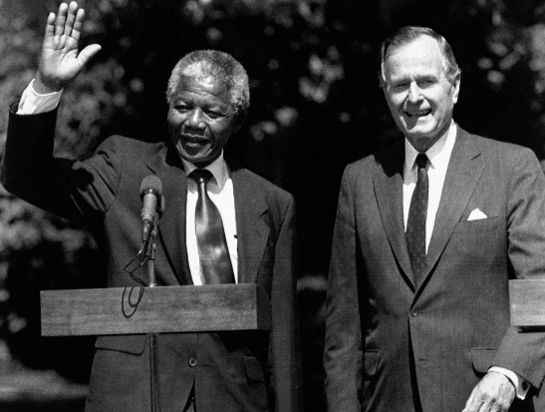
While China resisted changes, long overdue ones were taking place in South Africa. For years, the South African government, controlled by whites, had maintained an oppressive system of rigid segregation known as apartheid. The leader of the antiapartheid movement, Nelson Mandela had been imprisoned since 1962. In the late 1980s, protests against apartheid within South Africa and around the globe grew. In the United States, many private firms divested, or withdrew investments, from South Africa. Congress imposed economic sanctions instead of fully divesting, not wanting to destabilize the struggling nation. President Bush met with Mandela after his release from jail in 1990 and endorsed the drive to bring democracy to South Africa. Soon after, apartheid began to be dismantled, and South Africans elected Mandela as their leader in 1994 in their first free elections.

Questions: Overall Was Bush’s Presidency Successful? Why or Why not?

Document E: Peacekeeping and Police Actions
With the fall of communism in 1991, the nation of Yugoslavia disintegrated into a bloody civil war. Bush chose not to send troops because he feared that the tangled conflict could embroil the United States in another Vietnam, Not until 1992 did he back a modest UN plan to restore peace in Bosnia, one of the new republics carved out of Yugoslavia. By then, more than 150,000 civilians had died.
The Bush administration acted more swiftly to protect human rights in Somalia. As part of “Operation Restore Hope”. United States Marines landed in this East African nation in December 1992 to help establish a cease-fire between rival warlords and to deliver food to hundreds of thousands of starving people. The American humanitarian mission reinforce UN efforts at peace-keeping and relief. Even some of Bush’s most persistent critics applauded his decision to intervene in Somalia

Directions: Watch: Bush on doing “God’s Work”: https://www.youtube.com/watch?v=tgCeFXeuE4U

Questions: Overall Was Bush’s Presidency Successful? Why or Why not?

Document F: Persian Gulf War
The most important foreign policy challenged faced by the Bush administration took place the Persian Gulf. On August 2, 1990s, Iraq invaded its tiny neighbor Kuwait. Nearly 150,000 Iraqi troops quickly overran Kuwaiti forces.
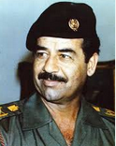
The war began with Saddam Hussein, Iraq’s ruthless dictator, who had run the Middle Eastern nation with an iron fist since 1979. By invading Kuwait, Hussein south to take over Kuwait’s rich oil deposits. With Kuwait in his power, Hussein would control nearly 20 percent of the oil produced around the world. The United States feared how Hussein would use the influence that controlling such a large amount of oil would give him. In addition, nearby Saudi Arabia possessed even more massive oil reserved. The United States did not want Hussein to seek to gain control of those reserved next. President Bush made it clear that he would not tolerate Iraq’s aggression against its neighbor. He worked to build an international coalition and backed a UN resolution demanding that Iraqi troops withdraw.

Directions: Watch- George H W Bush Announces War against Iraq (January 16 1991) – write down what you agree with and what you don’t

https://www.youtube.com/watch?v=IFrnQHaQWoA

Questions: Overall Was Bush’s Presidency Successful? Why or Why not?

What were the cause(s) of the Persian Gulf War?

Document G: Operation Desert Storm

By late fall, about 700,000 troops had assembled in Saudi Arabia, including nearly 500,000 American forces. Britain, France, Egypt, and Saudi Arabia, among others, also sent troops. Other nations, for example Japan agreed to help pay for the costs of the operation. Initially, Bush hoped that the presence of these troops along with the economic sanctions against Iraq would convince Hussein to withdraw his soldiers. At the same time, the President asked for and received from Congress the authority to use force, if necessary, to back up the UN’s resolution that Iraq leave Kuwait.

Operation Desert Storm, is the name given to the American led-attack on Iraqi forces, began on January 16, 1991. General Colin Powell, the Chairman of the Joint Chiefs of Staff, and General Norman Schwarzkopf devised and executed a strategy that began with five weeks of devastating aerial bombardment on Iraqi force. Iraq countered by launching Scud missiles on both coalition forces and on Israel. These missiles did little serious damage, although they struck terror in the hearts of many who feared they were armed with chemical warheads.

On February 23, coalition troops stormed into Kuwait. Easily overmatched, Iraqi troops surrendered or fled, setting fire to Kuwaiti oil rugs along the way. Less than five days after the ground war began, Iraq agreed to a UN cease-fire. It had lost an estimated 25,000 soldiers. American deaths totaled 148. “We’ve kicked the Vietnam syndrome once and for all,” proclaimed Bush. President Bush chose to limit American actions to enforcing the UN resolution. The coalition’s forces would compel Iraq to leave Kuwait but would not continue on to Baghdad, Iraq’s capital, to topple Saddam Hussein. As a result, Hussein and his regime survived the war. Bush’s public approval rating skyrocketed.

Directions: Watch timeline of Persian Gulf War: Operation Desert Storm and write down key events in order: https://www.youtube.com/watch?v=l2TQ8a4LK3A

Questions: Overall Was Bush’s Presidency Successful? Why or Why not?

Document H:
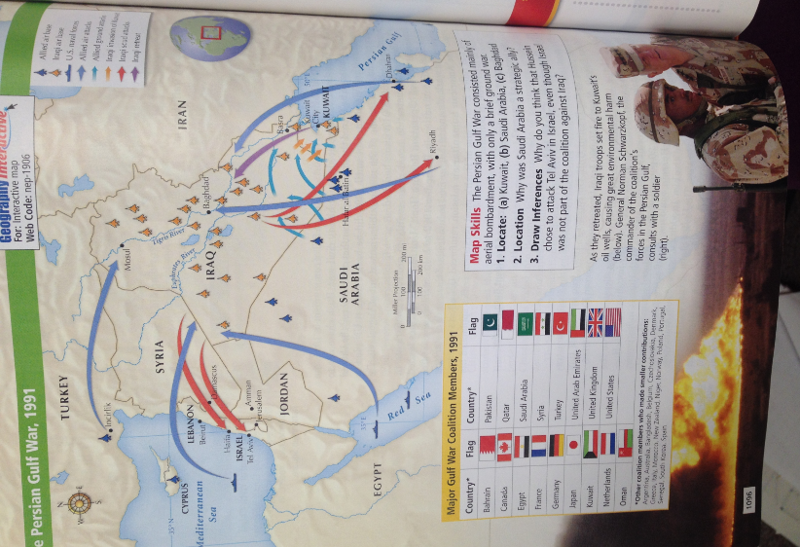

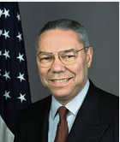
Document I: Colin Powell

The son of Jamaican immigrants, Colin Powell joined the army after college and served two tours of duty in Vietnam. He held several jobs in the army and in the government during the 1970s and 1980s. In 1989, President George H.W Bush named Powell Chairman of the Joint Chiefs of Staff. From that post, he guided the American victories in Panama and the Persian Gulf War. Powell later served as Secretary of State under George W. Bush

Questions: Overall Was Bush’s Presidency Successful? Why or Why not?

Overview of ALL- Answer:

What strategic political and economic interests caused the United States to become involved in the Persian Gulf War?

Why did President Bush respond differently to the crisis in Somalia, than he did to the Crisis in China?

Compare – How was the Persian Gulf War differently fought from the Vietnam War?

Why did the US led coalition stop after driving Iraq out of Kuwait?

Based on the Documents, What would you rate Bush presidency as and explain why? Use events to support your grade.

