Name___________________________________________ Date_____________________________
African Empires & Civilizations Project
DUE BY
Select one of the following to research in order to write a 1-2 page typed report. You must cite the source(s) of where you got your information from. If you are going to quote someone or use their words, make sure that you give proper credit.
DO NOT COPY AND PASTE OR PLAGIARIZE AN AUTHOR’S WORK - OR YOU WILL GET A ZERO !
If you need assistance in knowing how to give an author credit for their work….please ASK !
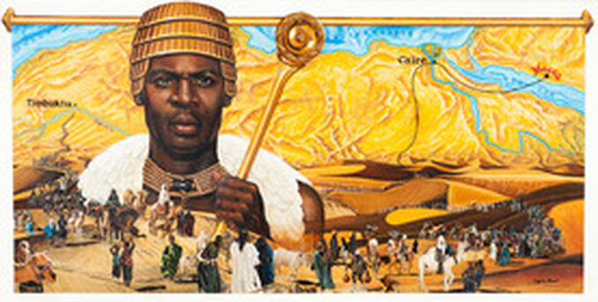

POSSIBLE TOPICS
- EGYPTIAN PHAROHS
- THE EMPIRE OF GHANA
- THE EMPIRE OF KUSH
- THE EMPIRE OF MALI featuring MANSA MUSA
- KING TUT
- AKHENETAN and NEFERTITI
- EGYPTIAN ARCHITECTURE
- THE EMPIRE OF SONGHAI
- THE EGYPTIAN PYRAMIDS

YOU MUST HAVE
- Size 12 font - double spaced - TIMES NEW ROMAN LETTERING

African Kingdoms PowerPoint Project
Choose one of the following kingdoms:
Songhai Benin Kongo
Directions: Use the internet to research your chosen kingdom and create a PowerPoint presentation that includes the following
- A map showing where the kingdom is located
- How the kingdom accumulated its wealth
- 1 important person from this kingdom
- What the kingdom looked like
- Aspects of culture
- Why the kingdom failed
- 1 extra fact of your choosing
CATEGORY | 4 | 3 | 2 | 1
Required Elements | The powerpoint includes all required elements as well as additional information. | All required elements are included on the powerpoint. | All but 1 of the required elements are included on the powerpoint. | Several required elements were missing.
Content - Accuracy | At least 7 accurate facts are displayed on the powerpoint. | 5-6 accurate facts are displayed on the powerpoint. | 3-4 accurate facts are displayed on the powerpoint. | Less than 3 accurate facts are displayed on the powerpoint.
Graphics - Relevance | All graphics are related to the topic and make it easier to understand. | All graphics are related to the topic and most make it easier to understand. | All graphics relate to the topic. | Graphics do not relate to the topic.
Attractiveness | The powerpoint is exceptionally attractive in terms of design, layout, and neatness. | The powerpoint is attractive in terms of design, layout and neatness. | The powerpoint is acceptably attractive though it may be a bit messy. | The powerpoint is distractingly messy or very poorly designed. It is not attractive.

