Early Antebellum (1820-1840s)
Abolition Resistance Meter
Very high level of resistance that harshly opposes slavery and calls for IMMEDIATE solutions
_____________________
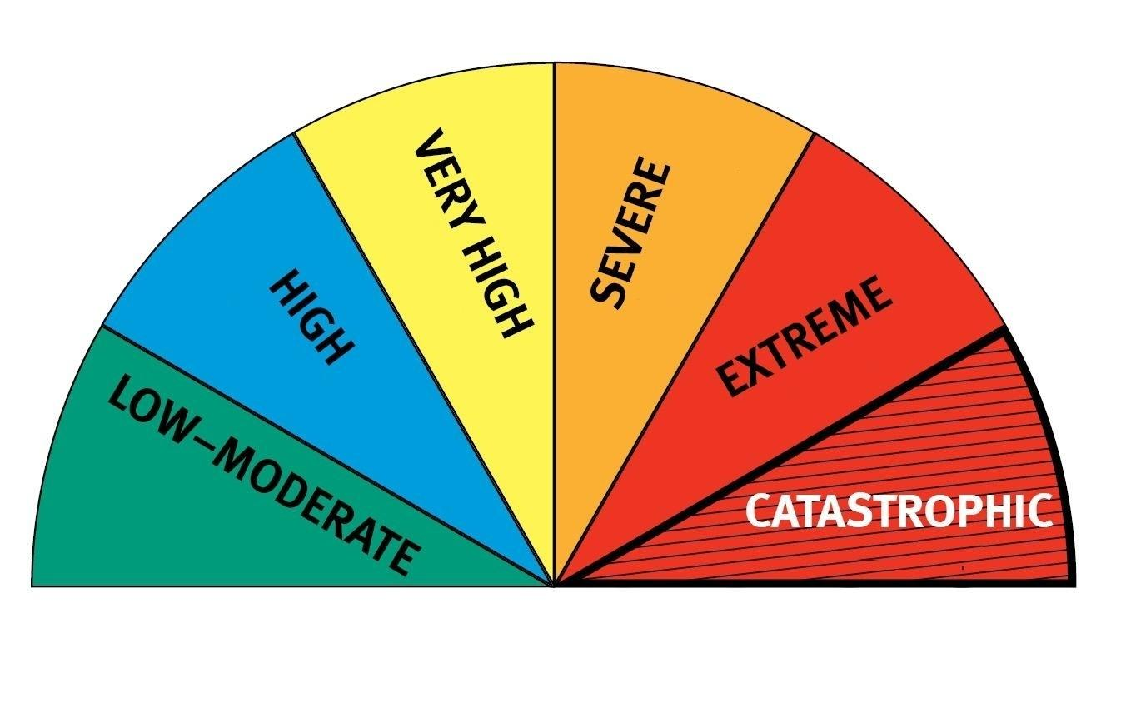
Lowest level of resistance against slavery
_______________________
Additional analysis:
Explain which of the four movements you believe was most successful in bringing about an end to slavery:

____________________

Highest form of resistance – seeks to physically overthrow slavery
_____________________
Options:
- Henry Clay’s American Colonization Society (ACS) B. Frederick Douglass (North Star) C. Nat Turner
D. William Lloyd Garrison (Liberator)

High level of resistance that works for a GRADUAL solution with government support
_____________________

Abolition Resistance Meter Sources

“On the subject of slavery . . . I will be as harsh as truth, and as uncompromising as justice.
. . . On this subject, I do not wish to think, or speak, or write, with moderation . . . I am in earnest - I will not equivocate - I will not excuse - I will not retreat a single inch - AND I WILL BE HEARD.”

William Lloyd Garrison, first issue of abolitionist newspaper The Liberator, 1831

“I have no fear for the ultimate triumph of free principles in this country. The signs of the times are propitious. Victories have been won by slavery, but they have never been won against the onward march of anti-slavery principles. The progress of these principles has been constant, steady, strong and certain. Every victory won by slavery has had the effect to fling our principles more widely and favorably among the people.—The annexation of Texas—the Florida war—the war with Mexico—the compromise measures and the repeal of the Missouri Compromise, have all signally vindicated the wisdom of that great God, who has promised to overrule the wickedness of men for His own glory—to confound the wisdom of the crafty and bring to naught the counsels of the ungodly.”

Frederick Douglass, The North Star, November 24, 1854

“Far, very far, was it from our purpose to interfere with the slaves, or to shake or affect the title by which they are held in the least degree whatever. We saw and were fully aware of the fact that the free white race and the colored race never could live together on terms of equality. . .. And we thought that the people of color should be voluntarily removed, if practicable, to their native country, or to the country at least of their ancestors … we never thought of touching in any manner the title to slave property."

Henry Clay “Speech to the American Colonization Society” January 24, 1848

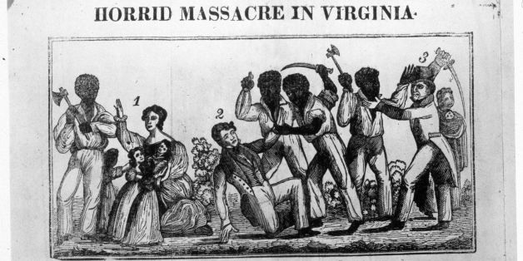
"Horrid Massacre in Virginia," in Samuel Warner, Authentic and impartial narrative of the tragical scene which was witnessed in Southampton County (Virginia) . . . (New York, 1831)

