Name________________
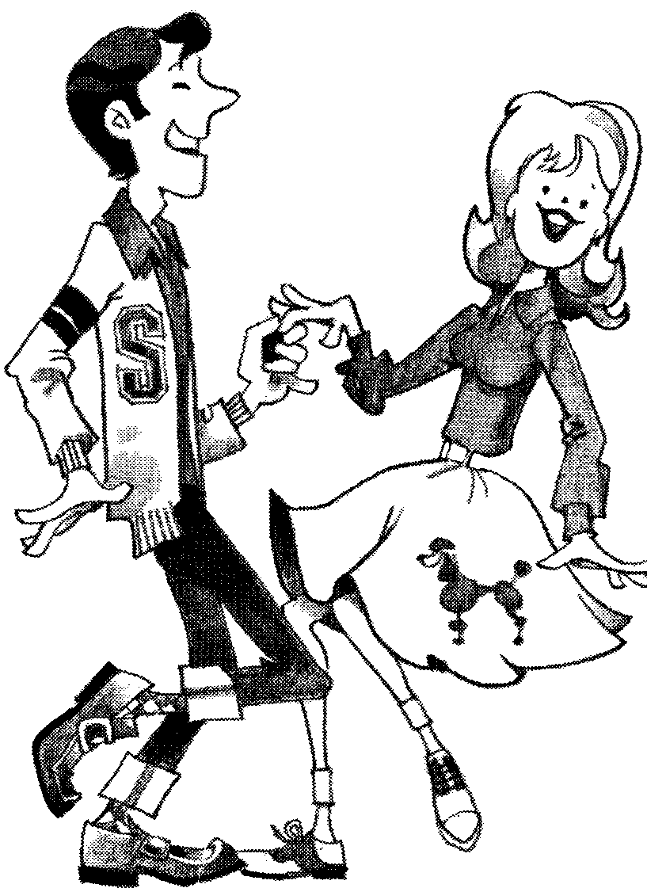
Postwar America / The 1950’s
Fifties Fact Sheet
Directions: Use the generalizations and facts on this page to help you answer the questions found on the ANALYZING THE FIFTIES WORKSHEET page.

- Most Americans were generally prosperous and happy with their life-styles.
- There was a considerable movement of families to the suburbs several miles outside large cities.
- Housing tracts such as Levittown sprang up everywhere, and personal home ownership increased.
- Americans spent billions of dollars on leisure-time activities.
- Education was held in fairly high esteem. High school and college graduates increased in number.
- The automobile industry grew into huge corporations and traffic increased tremendously.
- People desired and got new gadgets for their convenience around their homes and businesses.
- Food production in the U. S. reached new heights with farms producing 230 billion pounds of meat, 11 billion bushels of wheat, and 31 billion bushels of corn.
- American homes for the first time were heated by gas or oil, rather than by coal.
- In 1950, 3.1 million American homes had TV sets; by 1955, 32 million families.
- Population in America grew from approximately 150 million persons in 1950 to 180 million in 1959.
- The gross national production (the total of all goods and services in the American economy) grew from $290 billion in 1950 to $480 billion in 1959.
- The U. S. defense budget rose shockingly from $12 million in 1950 to $47 million in 1959.
- The annual salary per person in the U. S. grew from $3200 a year in 1950 to $5400 in 1959.
- Money spent for advertising grew from $5 million in 1950 to $11 million in 1959.
- The number of farms in America declined from 5500 farms in 1950 to 3500 in 1959.
- America’s suburban population in 1953 had grown to 30 million people, or 10,400,000 families.
- The production of the great American “hot dog” increased from 750 million pounds in 1950 to 1,050,000,000 pounds in 1960; potato chip production increased from 320 million pounds in 1950 to 532 million pounds in 1960.
- Little League baseball participants increased from 776 in 1950 to 5700 in 1960.
- Encyclopedia sales increased from $72 million in 1950 to $1300 million in 1960.
- Aspirin sales increased from 12 million pounds in 1950 to 18 million pounds in 1960.
- Vodka production increased from 100,000 gallons in 1950 to 9 million gallons in 1960.
- National forest campers increased from 1.5 million people in 1950 to 6.6 million in 1960.
- The best-selling book (non-fiction) in the years 1952, 1953, and 1954 was the Holy Bible, which averaged over 1.3 million copies each of the three years.
- New magazines of the 1950s included TV Guide (the biggest seller), Playboy, Sports Illustrated, and Mad.
- Americans increased their aid to foreign countries from $4.5 million in 1950 to %5.5 million in 1959.
- Millions of miles of freeway, turnpikes, and highways were constructed in the U. S. in the fifties, usually funded by the federal government.

Analyzing the Fifties Fact Sheet
Directions: Using the ANALYZING THE FIFTIES handout, write brief sentences or statement answers to numbers 1 thru 5. Then write two or three hypotheses under number 6.

- What pictures of Americans and American life in the 1950s emerge from these statistics and facts?

- What can these same statistics tell you about values held by Americans in the 1950s?

- Some observers have called Americans of the fifties an “affluent (wealthy) society.” What numbered items on the ANALYZING THE FIFTIES handout support this statement?

- What statistics are perhaps missing from the listing above that might give a more accurate and more honest picture of America during the 1950s (or any decade under study)?

- What do you find pleasing or unpleasing about life in the 1950s as you examine the statistics in the ANALYZING THE FIFTIES handout? Explain.

- Write two or three hypothesis of your own about life in the 1950s. (Remember: a hypothesis is an assumption a person makes based on what he/she knows/thinks about something. The statement is conjecture and is always a subject for further investigation.) Under your hypotheses place the numbers of the items on the ANALYZING THE FIFTIES handout that support your hypotheses.

Social Conformity in the 1950’s
During the 1950s, film and television producers made conscious attempts to portray an “ideal” American family in which mothers stayed at home and did housework, fathers went to work every day to make a living, and children went to school, came home and did their chores and homework, respected their parents, and never got into trouble. One such portrayal of the “ideal family” appears in the film you will view in this lesson. The film was intended to be “educational,” and was shown to many teenagers in school in the 1950s.
A Date With Your Family (1950)
http://www.archive.org/movies/details-db.php?collection=prelinger&collectionid=10468
Watch the film, than answer the following questions.
1. According to the narrator, what is the “important date” the boy and girl seen in the beginning of the video are looking forward to?

2. How do “Brother” and “Daughter” spend their time in the period prior to “Father” coming home for dinner? In what ways do their activities reinforce gender stereotypes? Give examples to support your answer.

3. In the video, how do the children show respect to their parents? Give at least three examples.

4. List at least three “don’ts” the narrator mentions during the film:

5. How are each of the family members dressed? Do you think the clothing styles of the children and their parents reinforce the message of the film and the values it’s trying to promote? Why or why not?

6. Do you feel the film accurately depicts the American family of the period? Explain your answer.

7. Which advice given in the film do you agree with? Which advice do you disagree with? Give at least three examples and explain why you agree or disagree with them.

8. Do you think this film has any educational value, or is it just a form of “propaganda” designed to keep 1950s children in line? Explain your answer.

9. The film is quite “dated,” and you probably found parts of it to be unintentionally funny. What do you think 1950s teenagers would have thought of the film? How effective do you think the film was at shaping the way 1950s teens behaved towards their families?

